TIBCO BusinessWorks 6.2.0 Silent Mode Installation

**PreInstallation Task:**

* Download TIBCO ActiveMatrix Businessworks software.
* Download Eclipse LGPL Software Assembly (Required for Linux and Solaris).
* Download Sunec LGPL(Oracle Elliptic Curve Cryptography Library) software assembly(optional). For SSL/TSL configuration.

**Installing in Silent Mode:**

* By default the installer uses the TIBCOUniversalInstaller_BW_<Version>.silent file

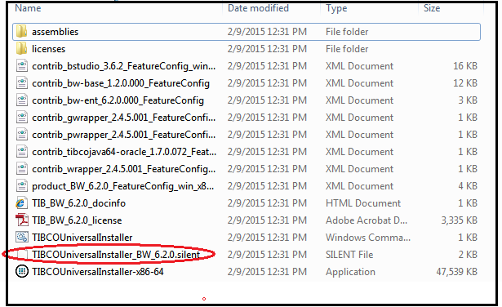

* Make a copy of this file and rename the file. Eg. Newfile.silent
* By the help of text editor( eg. Notepad), edit the installation location and features to install.

1. <entry key="installationRoot">C:\Program Files\tibco\bw</entry>

The above location is installation location. Change the location if required.

1. <entry key="environmentName">bw6</entry>

* For an existing environment, the installationRoot and environmentName must match with the pre-existing environment.
* For a non existing environment, the installationRoot and environmentName must be unique and does not match with the pre-existing environment.

1. <entry key="LGPLAssemblyLicenseAccepted">true</entry>

<entry key="LGPLAssemblyDownload">true</entry>

<entry key="LGPLAssemblyPath">C:\tibco\thirdpartyDownload</entry>

If SSL/TSL configuration is not required then comment the below lines.

1. <entry key="useInstallProfile">true</entry>

<entry key="selectedProfiles">Typical,Runtime</entry>

The 'selectedProfiles' value is a comma separated list of profiles to install. If a profile is listed which does not exist, then it is ignored. At least one profile must be listed if useInstallProfile is set to true.

* Now Open the cmd (Console window), and navigate to the temporary directory where TIBCOBW_6.2 has been extracted.
* Run the silent installer by below command:

TIBCOUniversalInstaller.cmd –silent [-V responseFile=”newFile.silent” ]

